Vol. 2002.06
The Top Super
Newsletter of The Montgomery County Beekeepers Association

Summer Field Day
Our July meeting will be held on Saturday, July 13, from 10:30 AM to 3:00 PM at the Montgomery County Extension Office (see map on the right). Last year, the association paid for fried chicken and members brought other dishes: salads, vegetables, and dessert. We will talk more at this month's meeting, but I suggest we follow the same format this year.

Bring your bee suits. Some of our members (Charles, Robert, and Fernand) have hives at the ag office and will give an up-close "tour" to all interested.

At Our Next Meeting
Don Ivy will talk about beekeeping and answer any specific questions you have. As many of you know, Don has done just about everything when it comes to bees, from comb honey to queens, from mite control to honey bottling.

Since this is a very busy time for beekeepers, we'll leave lots of time for Don to answer all of our questions.

Q&A
Speaking of questions, here are some interesting bee facts. If anyone knows that you are a beekeeper, I'm sure that you've been asked similar questions. It might be good to keep this handy.

Q: How many flowers must honey bees tap to make one pound of honey?
A: Two million.

Q: How far does a hive of bees fly to bring you one pound of honey?
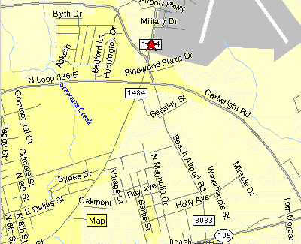
A: More than 55,000 miles.
Extension Office
9020 FM 1484

Q: How much honey does the average worker honey bee make in her lifetime?
A: From 1/2 to 1 teaspoon.

Q: How fast does a honey bee fly?
A: About 15 mile per hour.

Q: How much honey would it take to fuel a bee's flight around the world?
A: ~1 oz.

Q: What is mead?
A: Honey wine.

Q: What scotch liqueur is made with honey?
A: Drambuie.

Q: How many eyes does a honey bee have?
A: Five.

Q: What is the U.S. per capita consumption of honey?
A: 1.1 lbs.

Q: What state is known as the beehive state?
A: Utah.

Q: How many wings does a honey bee have?
A: Four, two fore wings and two hind wings.

Q: How many beekeepers are there in the U.S.?
A: A little over 200,000. Most are hobbyists.

Q: What states have the highest honey production?
A: South Dakota, North Dakota, Florida & California.

Q: How many colonies of bees are there in the U.S.?
A: Over 4 million.

Q: How many bees are in a hive?
A: About 50,000.

Q: How many eggs does the queen lay per day?
A: Up to 2000.
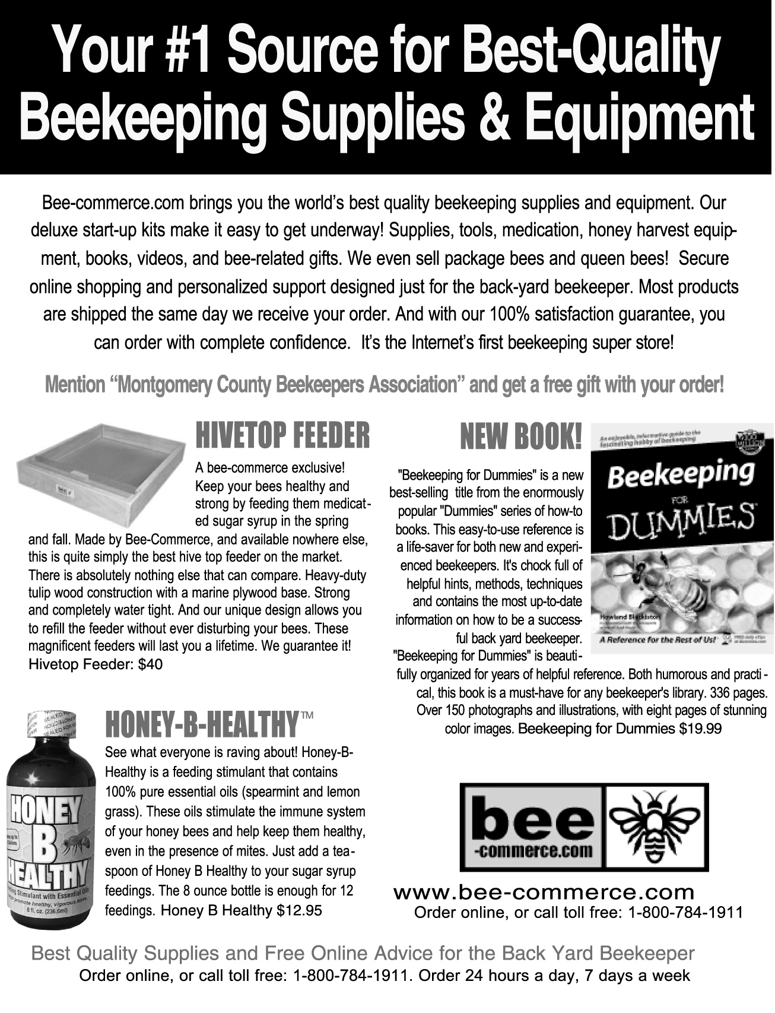

Site of the Month
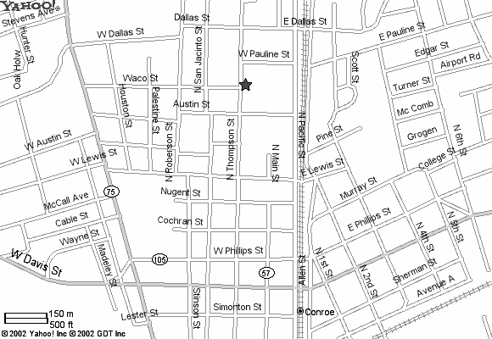
Check out our very own web site at http://beetalk.tripod.com/mcba.htm. This site is maintained by Robert and Dustin Talk. It has some good information on beekeeping and our society. It also has the monthly newsletter.
Travis Intermediate

Advertising
We are looking for additional advertisers. Our rates are reasonable and we offer year-round circulation. Even if you have a non-bee service or product, consider running an ad in our newsletter. We have the best subscribers in the world!

Remember: we will meet
in the library at
Travis Intermediate School.

Email comments to Bruce Blake at txbeekeeper77381@yahoo.com.

Sun | Mon |  | Tue |  | Wed |  | Thu |  | Fri |  |  | Sat
2 | 3 |  | 4 |  | 5 |  | 6 |  | 7 |  |  | 8  T.B.A. Summer Clinic
9 | 10 |  | 11 |  | 12 |  | 13  Bee Meeting  7:00 |  | 14 |  |  | 15
16  Father's Day | 17 |  | 18 |  | 19 |  | 20 |  | 21 |  |  | 22
23 | 24 |  | 251 |  | 26 |  | 27 |  | 28 |  |  | 29
30

June 2002

Watch your honey supers and install extras as needed. Harvest honey and replace wet supers on hive.

Yaupon; Chinese tallow; sweet, white & crimson clover; vetch; supplejack; horse mint



Bruce Blake, president & editor
Valerie Craft, 1st vice president
Randy Sneed, 2nd vice president
Patricia d'Agrella, secretary
Elvis d'Agrella, treasurer

Monthly meetings:
Second Thursday at 7:00pm
Travis Intermediate School
1100 N Thompson, Conroe

Montgomery County Beekeepers
91 N Floral Leaf Cir
The Woodlands, TX 77381

2000

